QUESTION – 2

1. Investigate (computationally) the cannon-shell trajectories ignoring both air drag and the effect of air density. Compare your result with exact solutions. Acceleration due to gravity depends on altitude; include this effect in your computational model by making some rational assumption

ASSUMPTIONS:

1. Variation in gravitational acceleration with height.
2. Air drag is neglected
3. Effect of air density is neglected
4. Target at same height as that of canon

INITIALIZATIONS:

1. Initial angle θ = 30◦
2. v_ini = 10 m/s
3. Radius of earth 6400km
4. Acceleration due to gravity go = 9.8 m/s2

ANALYTICAL SOLUTION:

Acceleration due to gravity changes with height,

$$g=g_{0}(1-2h/R)$$

Velocity in x direction

$$v_{x}=v_{0}cos⁡(θ)$$

Velocity in y direction

$$v_{y}=v_{0}sin⁡(θ)$$

Acceleration in x

$$a_{x}=\frac{d^{2}x}{dt^{2}}=0$$

Acceleration in y

$$a_{y}=\frac{d^{2}y}{dt^{2}}= -g$$

Displacement in x

$$x=v_{x}*t$$

Displacement in y

$$x_{y}=v_{y}*t+\frac{1}{2}*g*t^{2}$$

COMPUTATIONAL MODEL:

The matrix d0 has the values:

d0(1) has displacement in the x-direction and d0(2) has displacement in the y-direction. We used @ode45 to calculate the differential equations. The velocity along the x-direction remains constant, whereas the velocity along the y-direction changes. So, the acceleration along the x-direction is zero.

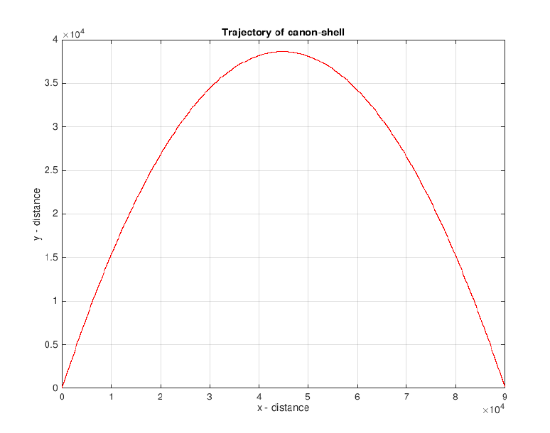

OBERSVATIONS:

1. The first observation that we make is that the velocity and the distance travelled by the object of mass m is independent of its mass whenever we neglect the effect of atmosphere.

2. The range travelled by the object will be maximum when the angle of projection is 45◦.

3. Since the acceleration changes with height, the velocity obtained by the body will decrease till it reaches the maximum height and then will start increasing till it reaches the maximum velocity.

(b)Investigate the trajectory of the canon shell including both air drag (proportional to square of velocity) and reduced air density at high altitudes. Perform your calculation for different firing angles; and determine the value of the angle that gives the maximum range.

$$F_{drag}= -bv^{2}$$

Density varies as follows

$$ρ= ρ_{0}e^{-\frac{y}{y_{0}}}$$

y is the altitude $y_{0}=1000m$

ASSUMPTIONS:

1. Gravitational acceleration is constant with height.

2. Drag force is proportional to v2

INITIALIZATIONS:

1. Initial angle, θ = 30◦
2. Initial velocity, v0 = 750 m/s
3. Radius of the Earth = 6400e3
4. Acceleration due to gravity = g0 = 9.8 m/s2
5. Velocity at any point of time $v=\sqrt{v_{x}^{2}+ v_{y}^{2}}$
6. Velocity in x direction $v_{x}=v_{0}cos⁡(θ)$
7. Velocity in y direction $v_{y}=v_{0}sin⁡(θ)$
8. Air drag constant = b
9. Fd air drag force = bv2
10. Change in atmospheric density $ρ= ρ_{0}e^{-\frac{y}{y_{0}}}$
11. Initial atmospheric density $ρ_{0}=1.225$

ANALYTICAL SOLUTION:

$$F_{dt}=\frac{ρ}{ρ_{0}}*F_{d}$$

$$\frac{b}{m} = 4e-5$$

Thus the acceleration in x

$$a_{x}= -\frac{b}{m}*e^{\frac{x}{x_{0}}}*v*v_{x}$$

Acceleration in y

$$a_{y}= -g-\frac{b}{m}*e^{\frac{x}{x_{0}}}*v*v_{y}$$

Displacement in x

$$x = v_{0}cos(θ)t$$

Displacement in y

$$y = v_{0}sin\left(θ\right)* t-\frac{1}{2}\left(a_{y}\right)*t^{2}$$

COMPUTATINAL MODEL:

The matrix d0 has the values :

d0(1) has displacement in the x-direction and d0(2) has displacement in the y-direction. We used @ode45 to calculate the differential equations. The velocity along the x-direction remains constant, whereas the velocity along the y-direction changes. So, the acceleration along the x-direction is zero.

GRAPHS:

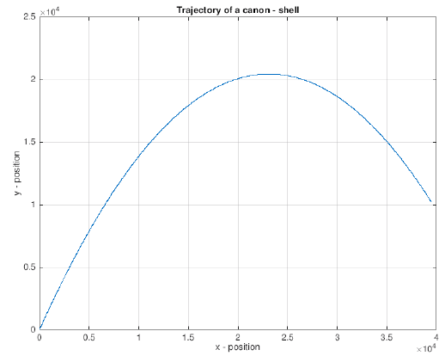

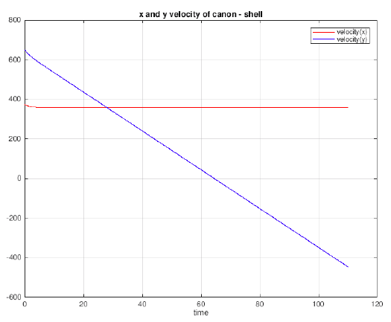

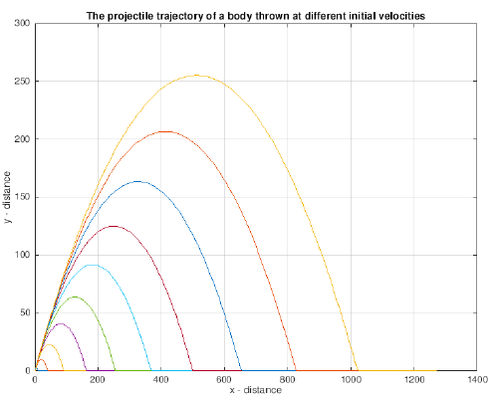

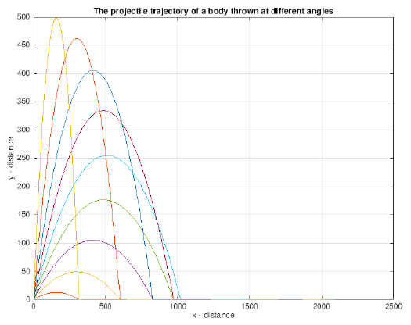

OBSERVATIONS:

The first observation that we make is that the velocity and the distance travelled by the object of mass m is dependent on its mass due to the presence of air drag force.

(c) Generalize the program so that it can deal with situations where the target is at a different altitude (higher or lower) than the canon. Investigate for both the cases. How the minimum firing velocity to hit a target varies as the altitude of the target varies.